**FABIEN BUG LIST 2**

1. **FIX BUG X CLOSE BUTTONS FOR ALL MODALS**

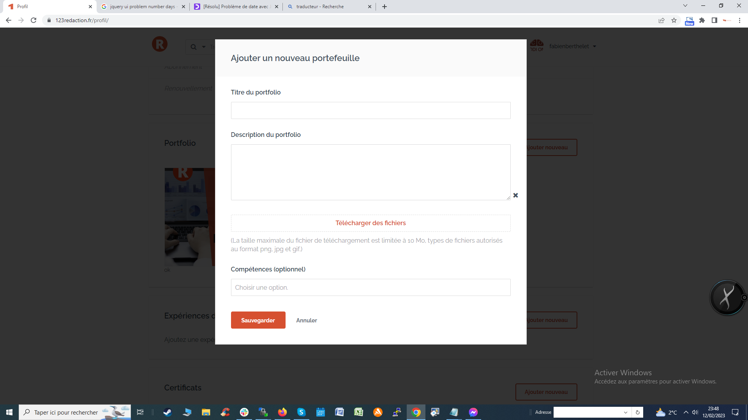

1. **FIX BUG LINE BREAKS FOR THE DESCRIPTION IN PROFILE PAGE , PROFILE LIST PAGE**

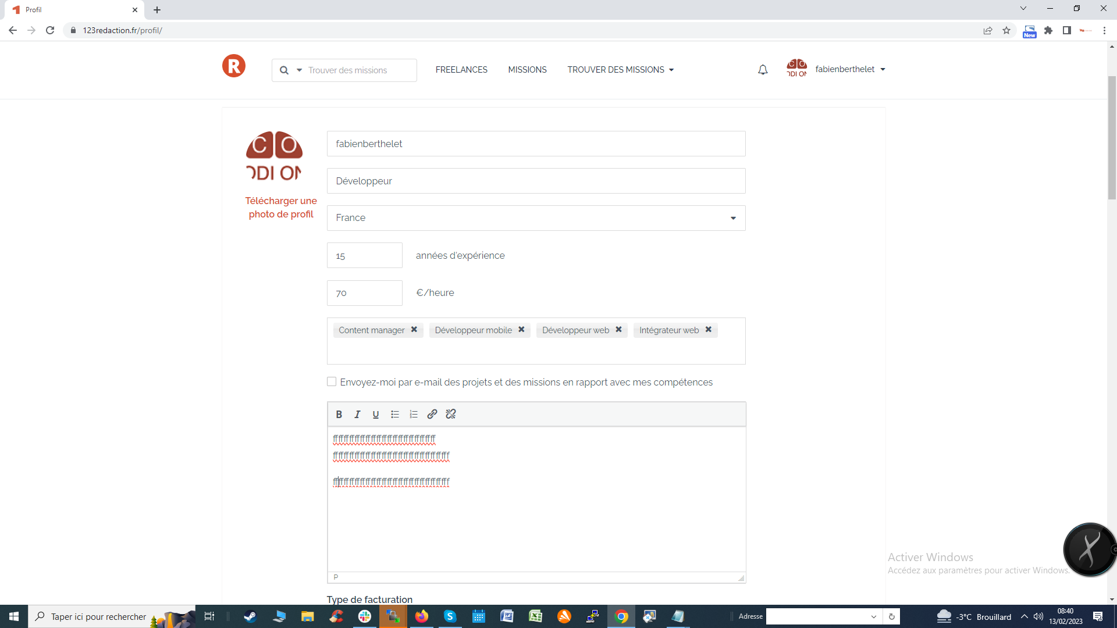

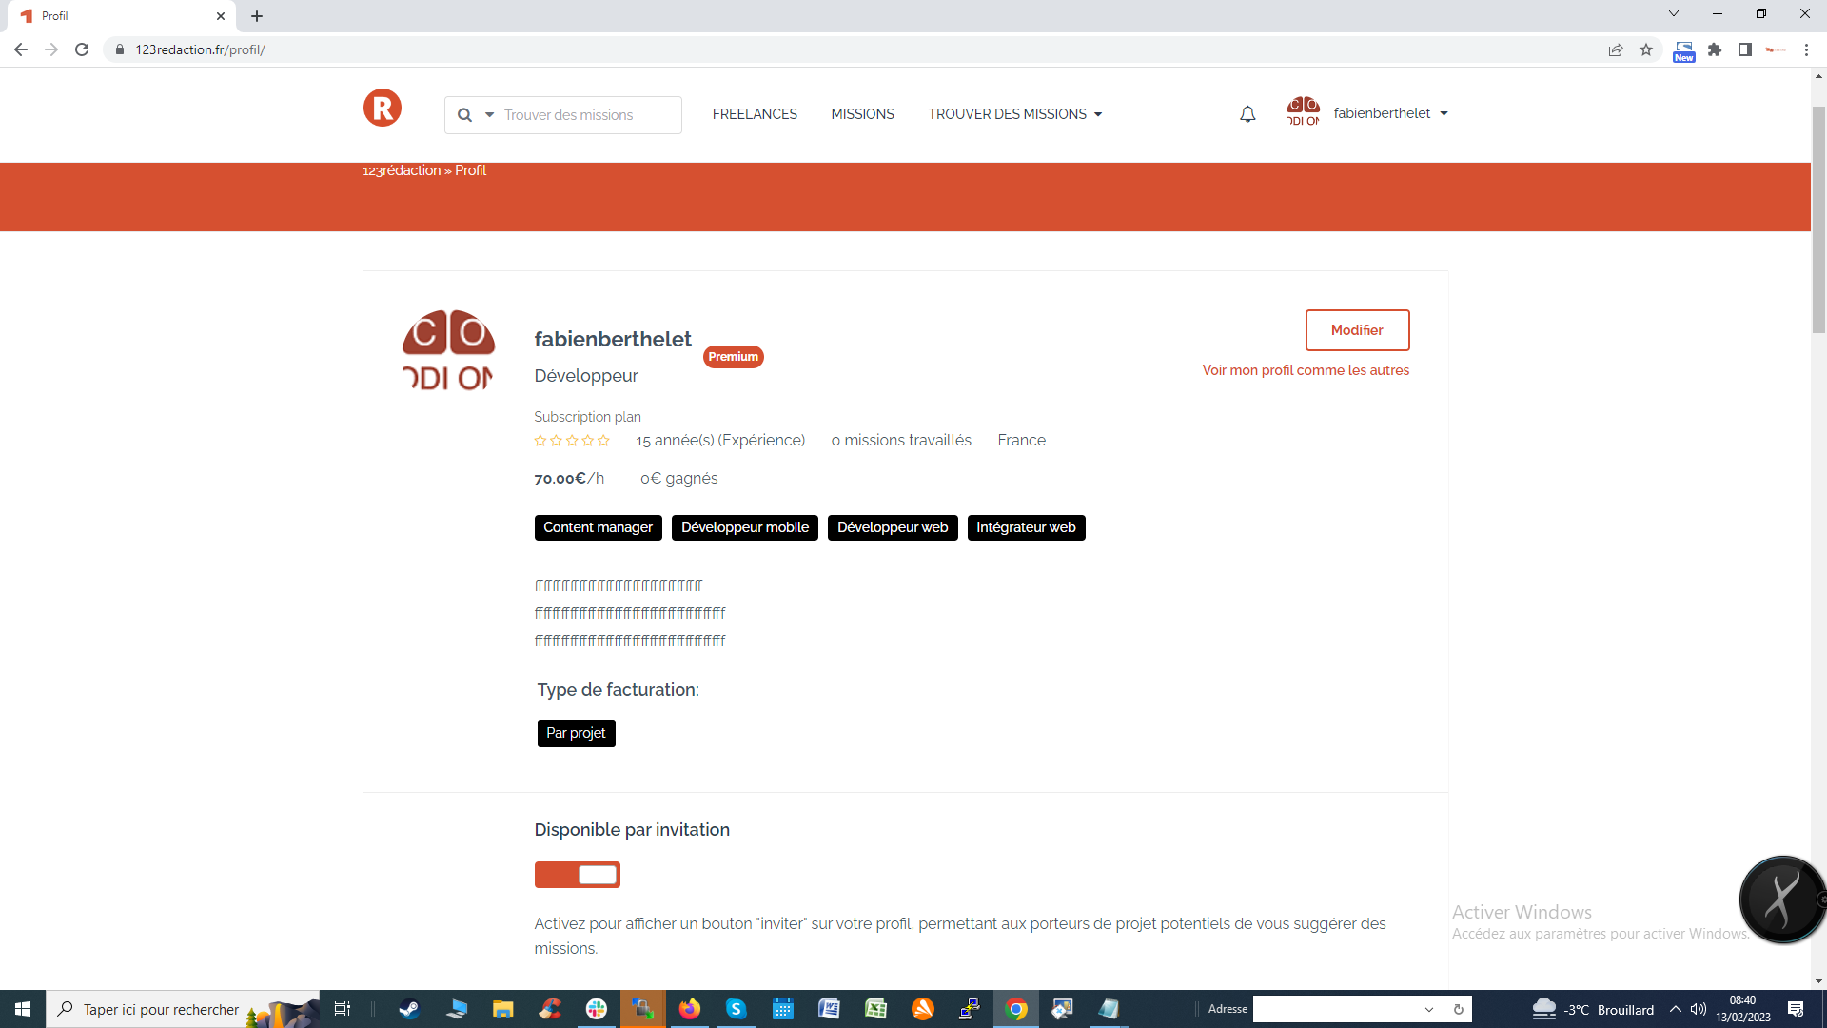

1. **CHANGE CSS FOR MODIFIER AND REMOVE BUTTONS**

**You have to change the css with a background-color: #db482c; color: #ffffff; padding: 3px;**

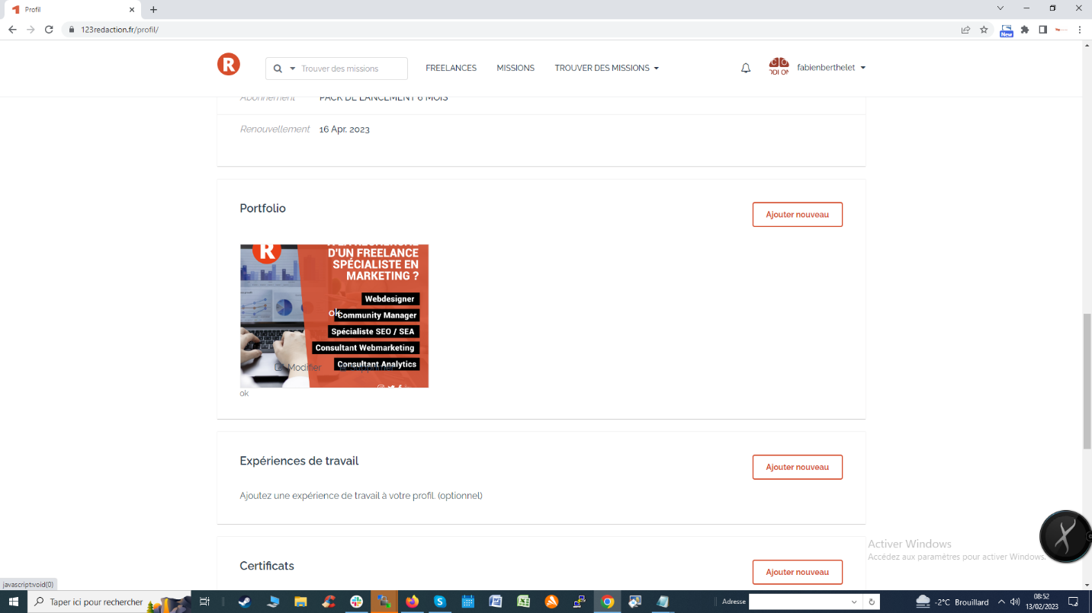

1. **FIX BUG MISSING FREELANCER FOR RANKING ORDER**